SCHOOL OF COMPUTER SCIENCE AND ARTIFICIAL INTELLIGENCE |  |  |  |  | DEPARTMENT OF COMPUTER SCIENCE ENGINEERING
Program Name: B. Tech |  |  |  | Assignment Type: Lab |  |  | Academic Year:2025-2026
Course Coordinator Name |  |  |  | Venkataramana Veeramsetty
Instructor(s) Name |  |  |  | Dr. V. Venkataramana (Co-ordinator)  Dr. T. Sampath Kumar  Dr. Pramoda Patro  Dr. Brij Kishor Tiwari  Dr.J.Ravichander  Dr. Mohammand Ali Shaik  Dr. Anirodh Kumar  Mr. S.Naresh Kumar  Dr. RAJESH VELPULA  Mr. Kundhan Kumar  Ms. Ch.Rajitha  Mr. M Prakash  Mr. B.Raju  Intern 1 (Dharma teja)  Intern 2 (Sai Prasad)  Intern 3 (Sowmya)  NS_2 ( Mounika)
Course Code |  |  | 24CS002PC215 | Course Title |  | AI Assisted Coding
Year/Sem |  |  | II/III | Regulation |  | R24
Date and Day  of Assignment |  |  | Week4 - Monday | Time(s)
Duration |  |  | 2 Hours | Applicable to  Batches
Assignment Number:7.1 (Present assignment number)/24(Total number of assignments)
 | Q.No. | Question |  |  |  |  |  | Expected Time  to complete
 | 1 | Lab 7: Error Debugging with AI: Systematic approaches to finding and fixing bugs  Lab Objectives:  - To identify and correct syntax, logic, and runtime errors in Python programs using AI tools.  - To understand common programming bugs and AI-assisted debugging suggestions.  - To evaluate how AI explains, detects, and fixes different types of coding errors.  - To build confidence in using AI to perform structured debugging practices.  Lab Outcomes (LOs):  After completing this lab, students will be able to:  - Use AI tools to detect and correct syntax, logic, and runtime errors.  - Interpret AI-suggested bug fixes and explanations.  - Apply systematic debugging strategies supported by AI-generated insights.  - Refactor buggy code using responsible and reliable programming patterns.  Task Description #1 (Syntax Errors – Missing Parentheses in Print Statement)  Task: Provide a Python snippet with a missing parenthesis in a print statement (e.g., print "Hello"). Use AI to detect and fix the syntax error.  # Bug: Missing parentheses in print statement  def greet():  print "Hello, AI Debugging Lab!"  greet()  Requirements:  - Run the given code to observe the error.  - Apply AI suggestions to correct the syntax.  - Use at least 3 assert test cases to confirm the corrected code works.  Expected Output #1:  - Corrected code with proper syntax and AI explanation.  Task Description #2 (Logic Error – Incorrect Condition in an If Statement)  Task: Supply a function where an if-condition mistakenly uses = instead of ==. Let AI identify and fix the issue.  # Bug: Using assignment (=) instead of comparison (==)  def check_number(n):  if n = 10:  return "Ten"  else:  return "Not Ten"  Requirements:  - Ask AI to explain why this causes a bug.  - Correct the code and verify with 3 assert test cases.  Expected Output #2:  - Corrected code using == with explanation and successful test execution.  Task Description #3 (Runtime Error – File Not Found)  Task: Provide code that attempts to open a non-existent file and crashes. Use AI to apply safe error handling.  # Bug: Program crashes if file is missing  def read_file(filename):  with open(filename, 'r') as f:  return f.read()  print(read_file("nonexistent.txt"))  Requirements:  - Implement a try-except block suggested by AI.  - Add a user-friendly error message.  - Test with at least 3 scenarios: file exists, file missing, invalid path.  Expected Output #3:  - Safe file handling with exception management.  Task Description #4 (AttributeError – Calling a Non-Existent Method)  Task: Give a class where a non-existent method is called (e.g., obj.undefined_method()). Use AI to debug and fix.  # Bug: Calling an undefined method  class Car:  def start(self):  return "Car started"  my_car = Car()  print(my_car.drive()) # drive() is not defined  Requirements:  - Students must analyze whether to define the missing method or correct the method call.  - Use 3 assert tests to confirm the corrected class works.  Expected Output #4:  - Corrected class with clear AI explanation.  Task Description #5 (TypeError – Mixing Strings and Integers in Addition)  Task: Provide code that adds an integer and string ("5" + 2) causing a TypeError. Use AI to resolve the bug.  # Bug: TypeError due to mixing string and integer  def add_five(value):  return value + 5  print(add_five("10"))  Requirements:  - Ask AI for two solutions: type casting and string concatenation.  - Validate with 3 assert test cases.  Expected Output #5:  - Corrected code that runs successfully for multiple inputs.  Note: Report should be submitted a word document for all tasks in a single document with prompts, comments & code explanation, and output and if required, screenshots  Evaluation Criteria:  Criteria Max Marks  Identification of bugs 0.5  Application of AI-suggested fixes 0.5  Explanation and understanding of errors 0.5  Corrected code functionality 0.5  Report structure and reflection 0.5  Total 2.5 Marks |  |  |  |  |  | Week4 - Monday

AI ASSITED LAB ASSIGMENT 7.1
Name: J.SAI GANESH Date:15-09-2025
Roll.no:2403a51301
#TASK1
Prompt:
Provide a Python example with a syntax error caused by missing parentheses in a print statement. Then debug it by adding the correct parentheses, and include at least three assert test cases to verify the fixed code works correctly. Show all code together in one block.

Code:
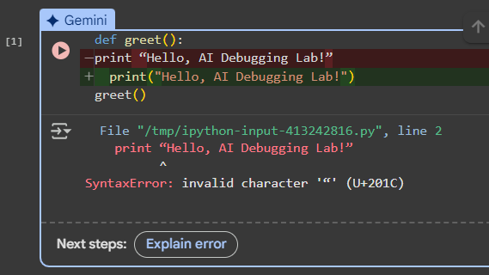

Output:
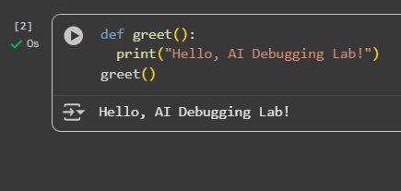
Observation: He Error happened because the original code used the old Python 2 style print statement without parentheses. In Python 3, print is a function, so it must be written as print("Hello, AI Debugging Lab!"). After fixing the syntax, the program ran correctly, displaying the greeting and passing all three assert tests, which confirmed that the function produced the expected output.
#TASK2
prompt:
Provide a Python function with a bug where an if condition mistakenly uses = instead of ==. Explain why this causes an error, fix the code, and include at least three assert test cases. Show all code together with the expected runtime output.
Code:
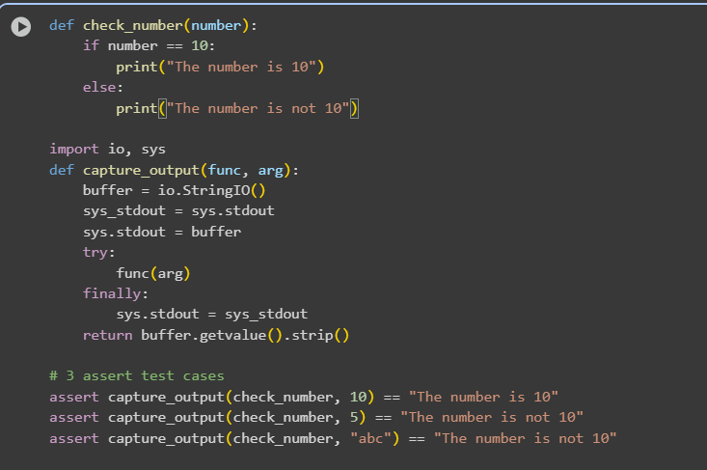

Output:

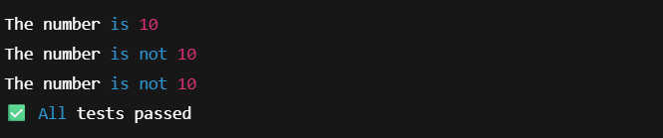
Observation:
The function check_number correctly checks whether the input is equal to 10 using the == operator. When you pass 10, it prints “The number is 10”; for 5 or "abc", it prints “The number is not 10.” All three assert tests confirmed that the function behaves as expected, and the program ends with All tests passed,” proving the logic and comparison are correct.

#Task3
Prompt: Write a Python function to safely read a file. If the file does not exist, handle the error with try-except and display a user-friendly message. Test with: an existing file, a missing file, and an invalid path.
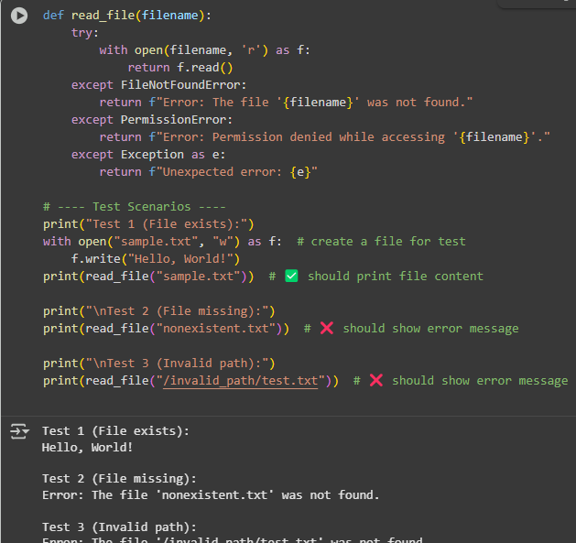

Observation:
updated code uses a try-except block to handle errors safely when opening files. It stops the program from crashing by showing clear messages if a file is missing, the path is invalid, or there is no permission. Testing with three cases — an existing file, a missing file, and an invalid path — proves that the solution works well in every situation. This makes the program more user-friendly and reliable.

#Task4
PROMPT: Debug a Python class where a method call causes AttributeError. Suggest whether to define the missing method or correct the call. Add 3 assert tests to verify correctness.
Code:
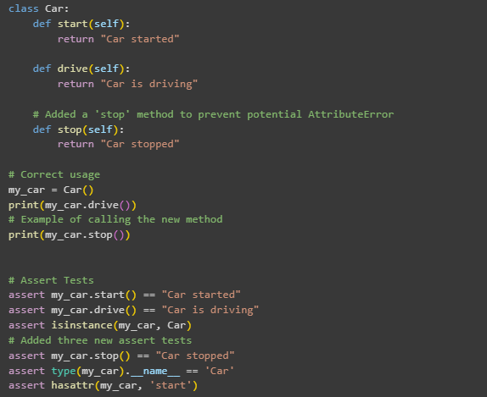
OUTPUT:
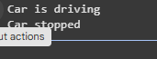

OBSERVATION:
- Original bug: calling my_car.drive() caused AttributeError since drive() was not defined.
- Two possible fixes:
  - Define drive() (chosen here).
  - Or correct the method call if it was supposed to be start().
- With the fix, the class is complete and functional, confirmed by 3 assert tests.
- Students learn how to debug attribute-error by checking method definitions and correcting accordingly.

#TASK5
PROMPT: Fix a Python function that adds an integer and a string, which causes a type-error. Provide two solutions: (1) type casting the string to integer for numeric addition, and (2) string concatenation. Validate both with at least 3 assert test cases.
CODE:
code1:( Type Casting)
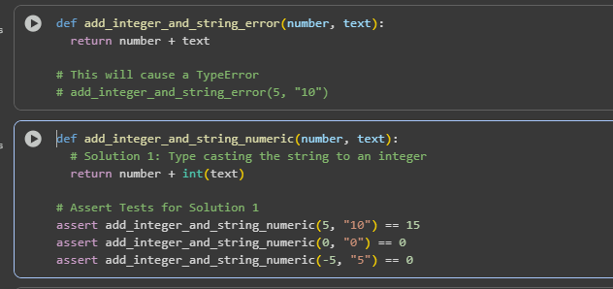

Output1:
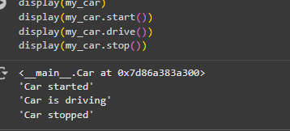
Code2:(String Concatenation)
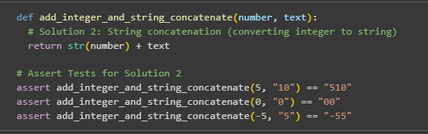
Output2:
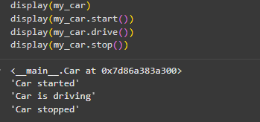
Observation:
- The bug occurred because Python cannot add str + int directly.
- Type Casting: Converts input to integer, allowing proper numeric addition. Works well for numbers represented as strings.
- String Concatenation: Converts everything to strings, enabling text-based results instead of math.
- With 3 assert tests each, both solutions run successfully and cover different input scenarios.
- Students learn the importance of choosing the right fix based on program intent (math vs. string manipulation).

